
Bath & Wells Diocesan Association of Change Ringers
President: THE RIGHT REVEREND THE LORD BISHOP OF BATH AND WELLS
The BELL FUND of the Association is Registered Charity No. 73962
Master |  | General Secretary & Treasurer
REV MARK JACKSON |  | DAVID PARFREY
12 PALMER STREET |  | 9 KINGSTON AVENUE
SOUTH PETHERTON |  | SALTFORD
SOMERSET TA13 5DB |  | BRISTOL BS31 3LF
01460 242171 |  | 01225 873887
Master@bath-wells.org |  | General.Secretary@bath-wells.org

Annual General Meeting, Saturday 13th May 2022

AGENDA

- Opening Items
  - Attendance and Apologies
  - Welcome – Master
  - Remembering Friends
  - Minutes of previous Annual General Meeting held on 14th May 2022 (Paper 1, pages 2 - 6)
  - Matters Arising (not covered elsewhere)
- Elections
  - Election of New Members
  - Members for 75 & 50 Years
  - New Honorary Life Members – David Bromwich
  - Election of Officers (Paper 2, page 7)
  - Ratification of election of non-resident life members elected prior to peals
- Officers Reports (Paper 3)
  - Master’s Report (Page 8)
  - General Secretary’s Report (Page 9)
  - Treasurer’s Report (Pages 10 – 14)
  - Tower Advisor’s Report (Page 15
  - Ringing Support Fund Officer’s Report (Page 15)
  - Education Officer’s Report (Pages 16 – 18)
  - Edna Grabham Memorial Education Fund Report (Page 19)
  - Safeguarding Officer’s Report (Page 20)
  - Peal Secretary’s Report (Page 21)
  - Quarter Peal Secretary’s Report (Pages 22 - 23)
- Information
  - Association Striking Competitions (Paper 4, page 24 - 25)
  - Update on new Website
  - ‘Festival of Ringing’
  - 2024 AGM – Ilchester Branch, Saturday 11th May 2024
- Other Business
  - Any Other Business – to be notified to General Secretary by Monday 8th May
  - Vote of Thanks
- Close

Paper 1
Bath & Wells Diocesan Association of Change Ringers
President: THE RIGHT REVEREND THE LORD BISHOP OF BATH AND WELLS
The BELL FUND of the Association is Registered Charity No. 273962
Treasurer | Master | General Secretary
LIZ LANE | REV MARK JACKSON | DAVID PARFREY
17 STARRS CLOSE | 12 PALMER STREET | 9 KINGSTON AVENUE
AXBRIDGE | SOUTH PETHERTON | SALTFORD
SOMERSET BS26 2BZ | SOMERSET TA13 5DB | BRISTOL BS31 3LF
01934733119 | 01460 242171 | 01225 873887
Association.Treasurer@bath-wells.org | Master@bath-wells.org | General.Secretary@bath-wells.org

Draft Minutes of the 2022 Annual General Meeting
Held at 3:15pm on Saturday 14th May 2022 at Chilcompton Church Hall (following the AGM service at Midsomer Norton).

Welcome

The Master welcomed everyone to the meeting, particularly welcoming new members attending their first AGM. He observed how good it was to be meeting in person after the previous two years meetings by Zoom necessitated by the Pandemic. He opened the meeting with prayer for the Association, its members and the wider world.

Remembering Friends

The Master asked the meeting to take a moment to reflect on friends who we see no longer. The meeting remembered with affection the following:

During 2021
Michael Barker, Non- Resident Margaret Gillard, Hillfarrance (former Bath ringer) Mike Hamilton, Brushford
Pam Bellamy, Wilton Susan Harrison, Buckland Dinham
Valerie Boyce, Lydiard St Lawrence Monica Horseman, Farmborough
John Brunsdon, Glastonbury-St-John Steve Hyde-Gregory, Chard
Dorothy Bull, Paulton Bob Lock, Milborne Port
Jay Bunyan, Shepton Montacute Chris Neave, Rodney Stoke
John Colegate, Bathford Michael Pulvermacher, West Buckland
Alan Cooke, Rockwell Green Barry Quinton, Dunkerton
John Crole, Street James Shepard, Dowlish Wake
Bernard Dodd, Bleadon Betty Willcox, High Littleton
David Gay, Weston Super Mare Paul Williams, Taunton St Andrew
Doug Gill, Chilcompton

And during 2022
Margaret Chapman, Marston Bigot Jim Major, Doulting
Jeffery Knipe, Shepton Beauchamp Victoria Sutton-Thompson, Burnham on Sea
Reg Lee, Pitminster Margaret Whatmore, Pitminster

Attendance and Apologies

Forty members had signed the attendance book, and apologies had been received from the following members:.

Julian Back | Helen Beaufoy | Tony Cox | Yvonne Criddle
John Croucher | Carolyn Dawson | Karen Dunn | Tim Hawkings
Anna Hallett | John Hallett | Margaret Lee | Richard Lee
Sheila Matthews | Felicity Mussell | Mike Palmer | Debbie Parfrey
Helena Parfrey | Philippa Parfrey | Steffi Penney | Robert Perry
Julie Preece | Freda Prime | Jan Swan | Simon Tremewan
Geoff Walker | George Wyatt | Jan Wyatt | Roger Yeoman

Minutes of 2020 Annual General Meeting

The Master introduced the minutes of the previous AGM held by Zoom on Saturday the 8th of May 2021. He hoped everyone had had the opportunity to read the minutes in advance, and after confirming with the meeting that there were no objections, he approved the minutes as a true record.

Matters Arising (not covered elsewhere)

The Master confirmed with the meeting that there were no matters arising that would not be covered elsewhere in the agenda.

Officers Reports

Officers reports were read out, however they are not reproduced here as they are included in the Annual Report.

The Report Editor thanked everyone for their assistance in gathering the necessary information for the report. Recognising that all recent knowledge surrounding the report production had been lost with Jay’s untimely death in 2020, he also thanked everyone for their patience and support whilst he had brough things together, and conformed that good progress was being made in the production and he hoped to have it with the printers shortly. He confirmed that, in line with previous decisions, the report would be a little simplified, for example Peals would have a one line entry only rather than duplicating the full information as this can be accessed very easily on Bellboard. The meeting expressed its gratitude to Ken for picking up and undertaking this complex role.

Election of Officers for 22/23 (Annex 1)

The Master invited the General Secretary to introduce the table of officers provided in the meeting papers at Annex 1; this showed the current incumbents and proposals for changes to the Deputy Master and WebMaster positions.

The Deputy Master is traditionally nominated each year by the Branch hosting the AGM. Because we have not been able to have physical AGMs over the last two years we became out of sync. Frome Branch were due to host in 2020 and Terry Nicholls was nominated, and Terry has remained in post since. Glaston will host us in 2023, and they have nominated Marilyn Backhurst. The meeting agreed that from this AGM until the 2023 AGM, for one year only, we would have two Deputy Masters, Terry and Marilyn and they were both unanimously elected. From 2023 AGM we will revert to a single DM, with Marilyn as the nomination.

The GS then outlined a proposal from the Officers to appoint a part-time, paid, administrator. This would form a part of modernising and streamlining the Association’s business. There are presently a number of area’s of overlap between roles, that could usefully be removed by bringing our admin together, leaving Officers more able to concentrate on moving our Association forward and supporting members. We may as a part of the simplification and streamlining process that we may no longer require all of the present roles; equally we hope that through this others may feel more able to stand for office. This work is also designed to proceed in supportive tandem with the project to design and implement a new website.

The Administrator is likely to, amongst others, provide support to and remove overlaps between the Association Treasurer and General Secretary, and to support this the proposal includes the temporary merging of these two posts while the restructuring takes place with a view to probable re-separation when the restructuring is complete. The proposal to recruit an administrator, temporarily merge the General Secretary and Association Treasurer Roles and to restructure our administration and our key roles.
This was unanimously accepted, and David Parfrey was elected as General Secretary and Association Treasurer.

The Master thanked Liz Lane for her work as our Association Treasurer.

There was one further proposed change and that was for the role of Webmaster. Despite having wanted to step down for a number of years Julian Back had continued to hold the reins in this important area. However Paul Taylor had volunteered to take on the post, although it was recognised that Julian would continue to support the old Website to avoid Paul needing to get to grips with all the technical intricacies in a website about to be replaced, Julian would also work with Paul on the development of our new site together with the developer, Will Carey at the Big Dot Company. All other Officers had agreed to remain in post if elected. The change in Webmaster and confirmation of all other Officers in post was unanimously supported.

New Honorary Life Members Awards

The Master reported that there had been no new elections to Honorary Life Membership this year.

Ringing Support Fund Grants Awarded (Annex 2)

The Master also reported on Bell Fund Grant Decisions made (Annex 2 refers). Following the change in Financial Year in future the AGM will record grant decision that had been made during the reporting year. For information only it will also note any decisions made since the end of the reporting year.

  - Grants awarded in 2021 and previously reported at the 2021 AGM
      - Chew Magna - Grant awarded: £4,800.
      - East Harptree - Grant awarded: £6,400.
      - Staplegrove - Grant awarded: £8,900.

  - New Grants awarded in 2021 after the 2021 AGM
      - Compton Dando – Grant awarded: £1,200

  - For note, Grants awarded between Jan 1st 2022 and 2022 AGM
      - Keynsham – Grant awarded: £1,100

Financial

The Master invited the Treasurer to give an Oral update on the Association’s financial position.

The Treasurer was pleased to report that the Association finances we are in good shape but reminded the meeting that, as with the previous year, the pandemic had continued to affect activity over the last year.

She reminded members that the financial year now runs 1st January to 31st December, and so the reporting year was the calendar year 2021.

Turning to numbers. For the General Fund, the opening balance was £44,451. During the year there had been income of £17,207 and expenditure of £1,649, together with a transfer to the Ringing Support fund of £20,000 leaving a closing balance of £40,009. Expenditure continues to be low due to the pandemic.

Regarding the Bell Fund there was an opening balance of £85,095. During the year there had been income of £9,383 plus the £20,000 transfer from the General Fund. With grant payments made in the year of £14,173 a balance of £100,727 was carried over at the end of the year; live grant liabilities stand at £28,737, leaving an available balance of £71,990.

The Master again thanked the Treasurer for all her hard work, noting the thankless task for sorting out financial affairs but reaffirmed how grateful we are.

Ratification of election of non-resident life members elected prior to peals.

The Peal Secretary had reported that peals had again been scarce through the pandemic, and consequently he had not been made aware of any new Non-Resident Life Member elections. The Master noted his thanks to the Peal Secretary for his contribution.

Association Striking Competitions (Annex 3)

Proposals were introduced for the 2022 6 bell & 8 bell striking competitions, the full detail in included at Annex 3.
There followed some discussion, during which Matthew Higby questioned why members were only permitted to ring in either the 6 bell or the 8 bell competition. The General Secretary responded that there were two reasons:

  - As this year each Branch would only be entering one representative team in each competition there would only be 14 ropes available for each branch and so it had been felt that this rule would enable maximum inclusivity.
  - This year the 6 bell and 8 bell ‘competitions’ were being regarded as two ‘classes’ in a single ‘competion’, and the two classes would be running in parallel on the same day in separate towers. Whilst it is expected that the two towers will be close it would be too difficult for the same ringers to be in both towers.

Festival of Ringing – Spring 2023

The General Secretary reported that he was hoping that we might hold a ‘Festival of Ringing’ in 2023. The idea being a major Association wide celebration of our ART, a recruitment drive and an opportunity to publicise what we do.

Any Other Business

Matthew Higby informed the meeting that he hoped the 2024 National 12 bell competition final would be held at Chilcompton. If this is the case volunteers to assist with a number of activities would be needed.

Paul Feast asked if six new members from Cary Branch could be elected, he proposed from Bruton, Petra Dowell, Eloise Dowell and Joe Wheeler; from Wincanton Canna Whyte, and from Penselwood Harriet Palmer and Robert Backus. Elected en bloc the Master welcomed the new members to our Association.

2023 AGM

This will be hosted by Glaston Branch on 13th May 2023

Vote of Thanks

Ken Hallett thanked everyone who had helped with the AGM today, particularly the Reverend Guy Scott for taking the service, Charles Pipe-Wolferstan for playing the organ, Adrian Beck for the use of Chilcompton Bells, Mathew Higby for local arrangements and everyone who contributed to producing such a splendid tea.

Closing Remarks

The Master thanked everyone for coming to the AGM

Paper 2

Officers & Elections

Officer | Present Incumbent | Prepared to continue
Master | Mark Jackson | Mark Jackson
Deputy Master | Terry Nicholls/Marilyn Backhurst | Marilyn Backhurst
General Secretary | David Parfrey | David Parfrey
Treasurer | Liz Lane /David Parfrey (b) | David Parfrey
Tower Adviser | John Hallett (a) | John Hallett (a)
Assistant Tower Adviser | Bernard North (a) | Bernard North (a)
Education Officer | Jill Hansford | Jill Hansford
Deputy Education Officer | Janet Wyatt | Janet Wyatt
Membership Secretary | Debbie Parfrey (c) | David Parfrey (c)
Peal Secretary | Tony Cox | Tony Cox (d)
Quarter Peal Secretary | Clifford Nicholls | Clifford Nicholls
Report Editor | Ken Hallett | Ken Hallett
Safeguarding Officer | Steffi Penny | Steffi Penny
Librarian | David Bromwich | David Bromwich
Ringing Support Fund Officer | Margaret Lee | Margaret Lee
Association Bookstall | Janet Wyatt | Janet Wyatt
Webmaster | Julian Back / Paul Taylor (e) | Julian Back / Paul Taylor (e)
Independent Examiner | Anna Hallett | Anna Hallett
Central Council Representative | Paul Feast | Paul Feast
Central Council Representative | Michael Hansford | Michael Hansford
Central Council Representative | Matthew Higby | Matthew Higby
Central Council Representative | Charles Pipe-Wolferstan | Charles Pipe-Wolferstan
Central Council Representative | David Parfrey | David Parfrey
Notes:
- the Tower Advisory Service positions (greyed above) are appointed by the General Committee and not through election at the AGM.
- Although Liz stepped down as Treasurer at the last AGM she generously continued to cover the role whilst David needed time out.
- As agreed at 2022 AGM the roles of General Secretary & Association Treasurer have been temporarily amalgamated whilst a paid admin assistant is recruited, and roles restructured in this light. Since Debbie’s death David has covered her Membership Secretary role and it is proposed to add this to the restructuring activity as there are currently areas of overlap.
- Tony Cox has indicated that he is prepared to do one more year in post, but would like to stand down in 2024. Paul Feast has volunteered to stand for election ion 2024.
- Paul Taylor was elected Webmaster in 2022, however as we are working on a new Website Julian has kindly continued to support the existing website.

Paper 3
OFFICERS REPORTS

REFLECTIONS FROM THE MASTER – Mark Jackson

To my fellow Bellringers in the Association.
I want to say thank you to all those who quietly work in the background making our Association effective and workable. Many jobs are achieved by unsung heroes who have shown such dedicated service to the cause of ringing. The range is enormous but mustn’t go unheralded. Much free time is given so that we can improve our skills and keeping the wheels turning no mean feat. So my gratitude to all who ring, serve our community and make things happen. Many of our jobs lacklustre but are important. What we do we do for all, and so when you see a gap in the system, please volunteer and lend a hand.
We are moving into another new phase. We see a breakthrough in new developments, and the bells are more important than ever to ring out joyfully in what often appears to be a tired and challenged world. Encouragement, outreach, service, are indeed what we stand for. Churches would be much duller places without the bells and the call to worship is indeed a very ancient practice.
There is a massive push to revitalise our art, to encourage the young to learn in a safe environment and our responsibility to embrace the best we can achieve and give to the Association.
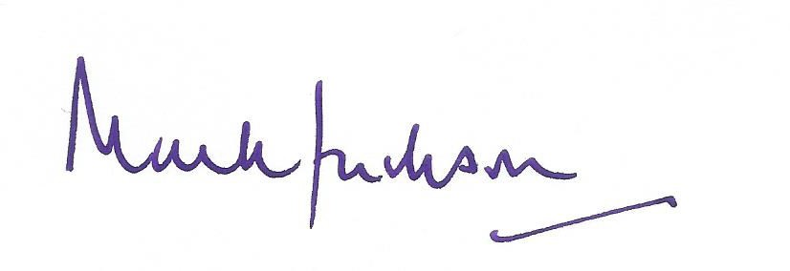
We look forward to new beginnings and even better achievements, greater skills and a common theme of mutual support. So thank you for what you have done in the past, what you offer for the next generation and what you bring to building up our community.

Mark Jackson

GENERAL SECRETARY’S REPORT – David Parfrey

Dear friends,
In my last report I spoke about our cautious return from the pandemic; the difficult days of 2020 and 2021 in particular will not be forgotten, and we remembered those lost to our art. Nevertheless it was time to look forward, a Platinum Jubilee beckoned; if ever there were a time to ring out in celebration this would be it. I also floated my thoughts of a Festival of ringing.
We held our AGM, a little light on attendance, perhaps understandably as for many caution still remained. Nevertheless we were very well looked after by the Frome Branch with our service at Midsomer Norton with tea and meeting at Chilcompton. Key decisions at our meetng included moving ahead with an all new website, the recruitment of a part-time administrator and modernisation and simplification of many of our ways of doing things. And so we left with heads high looking to a better future. As many will know life for me and our family was uptipped when my wife Debbie, died after a short illness. I have been ringing for nearly all of my life and a member of our Association for over 50 years, and during that time I have been fortunate to have made many friends. If these last months have taught me anything it is the value of friendship, I have been blessed to have received incredible support from friends across the Association and I thank you all. Also can I thank you for the patience you have shown me during this time. I am now moving ahead with the list of things we had planned so please do look out for things happening, please support the initiatives wherever and however you can. I will be keeping you up to date regularly with progress and there will be plenty of opportunities to get involved. The AGM, hosted very kindly by Glaston Branch this year will of course be a good place for updates and discussion.
Before I finish I would like to return to friendship. We are one of the larger associations and to me that gives us a responsibility to show the way. Perhaps one of two of our processes have fallen a bit behind times, but we are addressing that. But of people: when I learnt it was well known that wherever you went, as a ringer you would find yourself amongst friends. I certainly have found that is still the case, I hope, though, it is the case for all of us. Perhaps our ringing brings us peals or quarters in regular bands, perhaps it is our own practice nights or the opportunity to visit others. Ringing for service on Sundays and at other times will certainly feature, but wherever and however we ring we cannot do it alone, we depend on our friends and they depend on us. We are one Association, we are one membership, my hope is that in all we do we hold a hand of friendship to our fellow ringers, whoever they are and wherever they are, so that friendship and support for each other defines us in the Bath & Wells DACR.

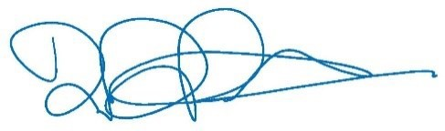

TREASURER’S REPORT – Liz Lane
Overall member numbers continue to decline, however there is still enough income to cover costs. Normally a
£20K transfer to the Ringing Support Fund is made, however surplus funds have been left to cover planned expenditure in the following year. No payments have been made under the return to ringing scheme, and now all unclaimed awards are cancelled.
Liz Lane, Association Treasurer

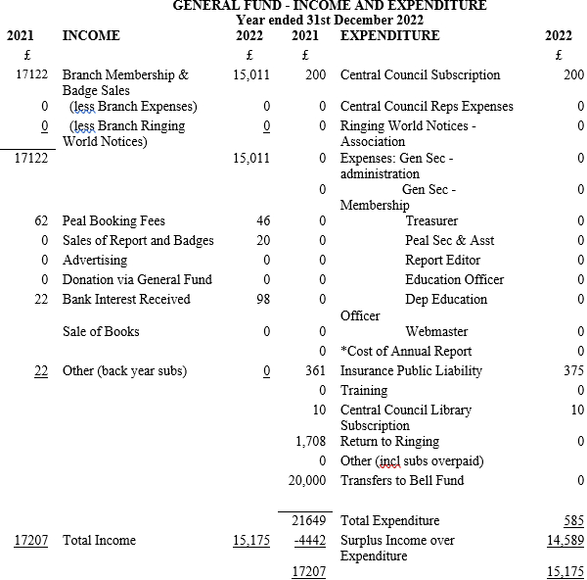

*Annual report printing costs cheque cleared in 2023

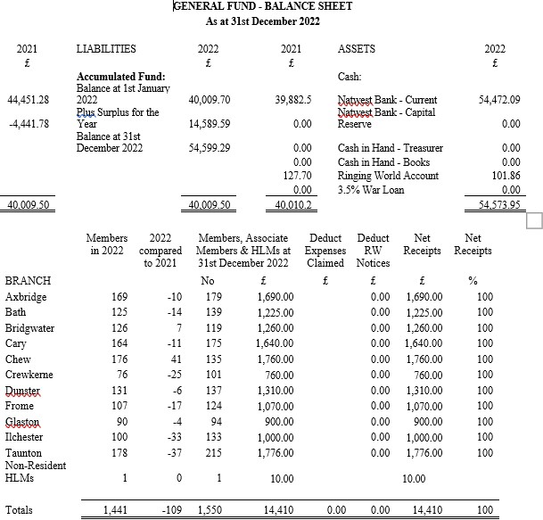

Ringing Support Fund Trustees’ Report 2022
The Ringing Support Fund continues to have a healthy balance with a number of grants approved during the year. Unfortunately a number of older grant approvals have expired because work has not started, the value of these awards is released back to the available balance. It is noticeable however that without the transfer in of surplus cash from the general fund, that income is low. Fund raising activity has dropped since covid, and understandably, some people are reluctant to attend gatherings which could raise funds. On behalf of the Trustees, I would like to thank all those who have made donations or have been involved in fund raising activities, but encourage members to re-engage with fundraising activity.
Liz Lane, Treasurer to the Trustees

ANNUAL REPORT OF THE TRUSTEES OF THE BATH AND WELLS DIOCESAN ASSOCIATION OF CHANGE RINGERS RINGING SUPPORT FUND FOR THE YEAR ENDED 31st DECEMBER 2022
Title of the Charity
The Bath and Wells Diocesan Association of Change Ringers Bell Fund. Charity Registration Number 273962. Inland Revenue Reference XN 44116

Objectives
- The provision of grants towards the repair, renovation or augmentation of bells and their fittngs (excluding ropes or masonry).
- The provision of a free advisory service on the maintenance and repair of church bell installations.
- The provision of instruction to bands of ringers in order to promote the art of church bell ringing.

Beneficial Area
The Diocese of Bath & Wells

Governing Instrument
Rule 19 of the Bath & Wells Diocesan Association of Change Ringers states:

“In accordance with Object iii the Association maintains a Ringing Support Fund. The Fund is an Incorporated Charitable Organisation and is governed through its own objects and rules. Decisions on the award of grants are made by the Fund Trustees. An annual report on its activity is presented to the General Committee”

Trustees
The Trustees of the Fund are the Master (Chair), the General Secretary, The Treasurer, The Ringing Support Fund Officer, The Tower Advisor and the Education Officer

Treasurer
The Treasurer of the Association, Ms E.Lane, 17 Starrs Close, Axbridge, BS26 2BZ, is also Treasurer of the Bell Fund on behalf of the Trustees.

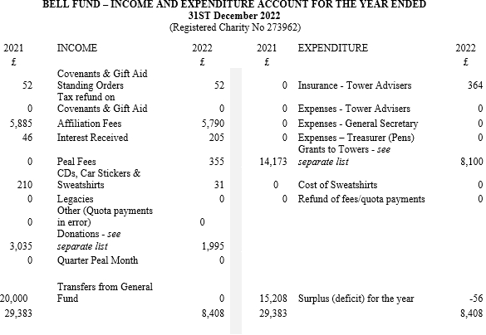

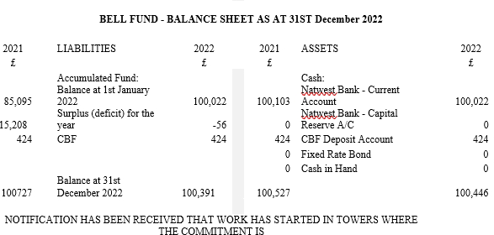

DONATIONS TO THE FUND £
Bridgwater Branch 50
Chew Branch Quiz 251
Glaston Branch 50
Taunton Branch Lottery 750
David Bromwich 300
David Purnell Funeral 390
Tickenham 50
Other 154
Total 1,995

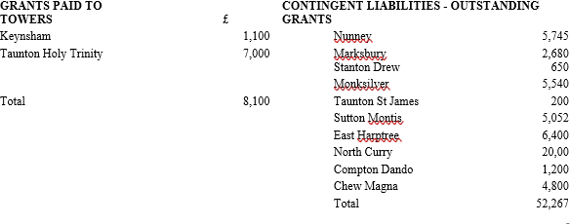

(post independent examination note: offers for Marksbury (£2,680), Monksilver (£5,540) & Sutton Montis (£5,052) have time-expired under the terms of the offers, and have therefore been withdrawn and the outstanding liabilities cancelled. The outstanding liability above is therefore reduced to £38,995.
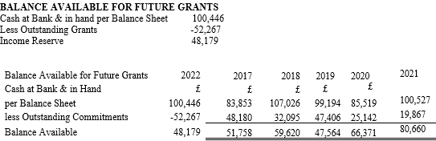

(nb. See post IE note above; outstanding commitments now reduced to £38,995)

Independent Examiner’s Report to the Trustees of the Bath and Wells Diocesan Association of Change Ringers’ Bell Fund

I report on the accounts of the Trust for the year ended 31st December 2022

Respective responsibilities of trustees and examiner
As the charity’s trustees you are responsible for the preparation of the accounts; you consider that the audit requirement of section 43(2) of the Charities Act 1993 (the Act) does not apply. It is my responsibility to state, on the basis of procedures specified in the General Directions given by the Charity Commissioners under section 43 (7)(b) of the Act, whether particular matters have come to my attention.

Basis of Independent examiner’s report
My examination was carried out in accordance with the General Directions given by the Charity Commissioners. An examination includes a review of the accounting records kept by the Charity and a comparison of the accounts presented with those records. It also includes considerations of any unusual items or disclosures in the accounts, and seeking explanations from you as trustees concerning any such matters. The procedures undertaken do not provide all evidence that would be required in an audit, and consequently I do not express an audit opinion on the view given by the accounts.

Independent examiner’s statement in connection with my examination, no matter has come to my attention:
- which gives me reasonable cause to believe that in any material respect the requirements
  - To keep accounting records in accordance with section 41 of the act and
  - To prepare accounts which accord with the accounting records and to comply with the accounting requirements of the act, have not been met: or
- to which in my opinion, attention should be drawn in order to enable a proper understanding of the accounts to be reached.
Anna Hallett Westonzoyland, 3rd March 2023
TOWER ADVISOR’S REPORT – John Hallett

The thirteen inspections and reports undertaken in the last Association year were allocated and carried out on a geographic basis by myself and Bernard North, to whom I am grateful.
Of the thirteen inspections carried out ten were Initial visits, requested by PCCs prior to any work being undertaken; the remaining three being final inspections to confirm the completed work prior to Bell Fund grant money being released.
The ten initial inspections included maintenance recommendations at Norton Sub Hamdon, Wootton Courteney, Horsington, Drayton, Fitzhead, Burnham on Sea and Cossington. Roping issues were discussed at Spaxton.
Refurbishment and a rehang was recommended at Tickenham and a complete rehang recommended at Holy Trinity, Taunton.
The three final inspections confirmed refurbishment work carried out at Keynsham and Chew Magna and the successful rehang at Holy Trinity, Taunton.

RINGING SUPPORT FUND OFFICER’S REPORT - Margaret Lee

In this year I received 3 grant application requests, of which 3 were approved and 2 grants have been paid. I would like to thank John and David for their support over the past year.

- Grants Awarded prior to 2022 and still live
  - Nunney - £5,745
  - Compton Dando - £1,200
  - East Harptree - £6,600
- New grants awarded in 2022 Financial Year
  - Keynsham - £1,100, work complete and grant paid
  - Taunton, Holy Trinity - £7,000, work complete and paid
  - North Curry - £20,000

EDUCATION OFFICER’S REPORT - Jill Hansford
In the last five months of 2021, once ringing was able to get back to as close to normal as it had been since the beginning of the pandemic, activities were organised in the branches to help people get back to ringing. It was wonderful to see ringers gradually returning to ringing at this time and beginning, what was for many people, the long road back to ringing fitness and competence. The start of 2022 saw the beginning of the first full year of ringing since the pandemic began. As well as working hard to re-start activities that were running before Covid, it has been brilliant to see really exciting developments across the Association. Behind these developments, of course, are the really keen and enthusiastic members of our branches leading this progress, and our very grateful thanks go to them.
In the Glaston Branch a teaching centre for the Branch has been planned and is being set up in Street. The necessary agreements have been obtained, risk assessments have been completed, the Association has provided the funding to install a simulator, and this is being installed at the present time. We will look forward to seeing it in action in the near future.
In the Cary Branch a ringing hub is being developed at Pitcombe and a simulator, funded by the Association, has just been installed. Regular learn to ring and improver sessions have already started. At a recent Open Day 14 potential new ringers and those who had just started ringing attended. The Branch are already working on settng up a second hub at Barton St David and we will look forward to hearing of the progress here shortly.
Progress is also being made with gettng the first simulator installed in the Crewkerne Branch. It is hoped that this will be at Curry Rivel. The idea was formally approved by the Branch at it’s recent AGM, and the PCC is now being approached for its agreement.
In the Bridgwater Branch special practices are being arranged to improve the standard of eight-bell ringing, ready to take on the other eleven branches in next year’s Association Striking Competition!!
In the Ilchester Branch the Ringing Master is going to visit all the towers with ringers and feed back to the Branch where support is needed. The Education Officer has volunteered to visit towers where learning is taking place. Other resources will be organised to help where it is required. An Open Day has also been organised at Martock where recruits are needed to develop a new band.
In the Axbridge Branch at Badgworth, where a new band was taught in recent years, the Education Officer, with help from ringers from Axbridge and Weston, has developed a learners practice every other week on a Thursday morning.
As a result of discussion at Education Officers Meetings it was decided that help was needed in the Branches in two areas. The first was for new Tower Captains or Tower Organisers. For various reasons, including returning from Covid to find that their Tower Captain was not returning and had not had time to prepare anyone to take their place, ringers were having to take on the role unexpectedly and were looking to their Branches/the Association for help. The second was for people needed to teach the learners that were coming forward as towers were short of ringers. Ringers who were prepared to do some teaching and needed help to refresh their skills or to gain the confidence necessary to begin teaching after doing an ART Course, etc, were also looking to their Branches/the Association for help. It was decided that the Association would run workshops covering these two areas. These were advertised in the late Autumn. 14 ringers applied for each workshop. They were divided into two groups, one covering the north and central part of the Association, and another covering the Western part of the Association. Two workshops were held before Christmas and another two were planned for the beginning of 2023. Further courses will follow throughout 2023.
These are all exciting developments for both the Branches and the Association and we look forward to very positive outcomes from them all.
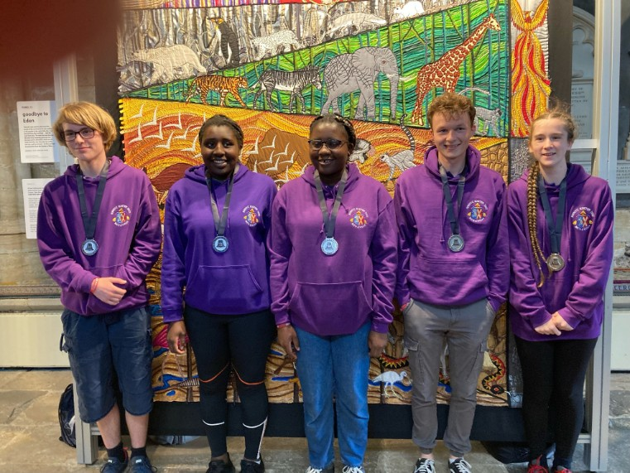
The Ringing World National Youth Contest was held in Exeter this year. Our Young Ringers did us proud as always. With some of the team new to striking competitions we were not competing for a trophy this year. After ringing in the striking competition, they joined with 200 plus young ringers to ring at several towers in and around Exeter, including the Cathedral. At the Cathedral the young ringers were offered the opportunity to ring the tenor, a challenge that was accepted by Melissa and other young ringers.
Our Young Ringers this year were Davina Bakam (Yeovil), Jack Higby (Chilcompton), Ronel Bakam (Yeovil), Igi Waugaman Reed (Clevedon), Will Hooper (Ashwick), and Melissa Hunt (Burnham on Sea). Melissa was the team captain and Conductor. They all had a brilliant day and are already thinking about next years contest in York on July 8th.

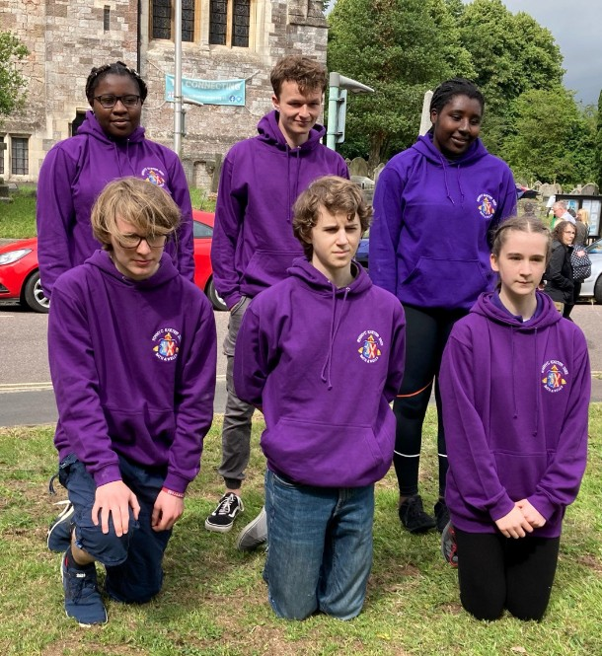
Young Ringers Activities. It is excellent to see young ringers active in almost all our branches. Young ringers from across the Association were invited to practices organised by Jan Wyatt to prepare for the National Youth Competition. In the Glaston Branch a mini-outing, a visit to the North Wotton mini-ring and a visit to Matthew Higby’s workshop to ring on the mini-ring and dumb-bell and tour the workshop, were arranged; and the Taunton Branch has run three practices during the school holidays for its young ringers. Unfortunately the Association Young Ringers Festival that had been planned for September had to be cancelled as it coincided with the death of the Queen.

Former Young Ringers. Marcus Ham continues to ring in the Axbridge Branch when back from university. Olivia Hunt, also from the Axbridge Branch, who began training as a teacher of ringing before the pandemic, has now moved with her job and lives in Northampton and is ringing in that area. In the Bath Branch, Nick Field, who has already been Branch Ringing Master, is now running a monthly special practice for 10-bell ringing at Bath Abbey. George Wyatt is still the Tower Maintenance Contact for the Chew Branch. From the Crewkerne Branch Frank Agar has followed Josh Jones to ring at university (Frank is at university in Birmingham). Sean Langton, who ringers in the Frome Branch may remember, picked up ringing again after university, when having qualified as a vet he lived in Glasgow, and rings in the Frome Branch when returning there. Sam Shead is now Ringing Master at Wells in the Glaston Branch. Rose-Anne Kimber from the Taunton Branch, married this year, rings with her husband Jack at Chester Cathedral. It is always good to hear that the young ringers we have taught are still ringing. For this to happen it is very important that we all continue the excellent work of encouraging young people into our towers
Tower Maintenance Contacts (TMCs). In the year before the pandemic our TMCs were only just beginning their work. As we came back to ringing they had a very important role in checking bells before ringing began again. In the first full year of ringing after the pandemic it is good to see our TMC’s active in almost all our branches. In the Axbridge Branch the TMC has been asked to look at the frame at Bleadon, and in the Chew Branch the TMC was asked to look at the bells at Tickenham and Kingston Seymour and to give advice on the work that was needed.
Tower checks were also carried out in the Bath, Bridgwater, Cary, Dunster, Glaston and Taunton Branches, advice was given on work needed, and the TMC’s helped to complete minor works in the Bridgwater, Dunster and Taunton Branches. The Bridgwater Branch BMC also prepared a report for Burnham on Sea. In the Cary Branch Castle Cary began ringing again after a long silence because of the condition of the tower pinnacles, and the bells were checked before ringing began again. In the Crewkerne Branch help was given with muffling bells. In the Glaston Branch the Cathedral bells were checked under contract with Taylors. A risk assessment was carried out at Street, and several safety-related items were identified together with remedial actions. In the Ilchester Branch the TMC rectified a problem at North Perrott, and having had problems at Chiselborough and East Coker referred to him helped to get the work referred to bell-hangers and general builders respectively. In the Taunton Branch the restoration work was completed at Holy Trinity Church, Taunton, by Taylors, assisted by the TMC’s, and other work at Holy Trinity also included installing sound control to make the bells quieter in the ringing room; helping to replace the organ air-box and stairs, all removed to get at the trap door; and making a new trap door entrance to the ringing room.
Training Teachers of Ringing. A lot of very hard work continues to be done to increase the number of teachers of ringing within the Association. Those teachers who were already training before the pandemic will be given time extensions to complete the modules that they were working on then. Both Module 1 and Module 2 courses were run during 2022 and 7 new teachers have begun training. A total of 8 Mentors and 25 Teachers have completed the award from across the Association.
Learning the Ropes. As part of the ART Course the New Teachers and their Mentors have to teach new ringers. The ringers that they teach are able to take part in a progressive scheme called ‘Learning the Ropes’. This is divided into five levels. This year, much time has been spent helping ringers to get back to what they were ringing before the pandemic and therefore far fewer certificates have been awarded. The Dunster Branch has awarded 10 Level 1, and 1 Level 3; and the Taunton Branch has awarded 3 Level 1 and 1 Level 2. This will undoubtedly pick up again in 2023.
Since work on the award began the Association has awarded 220 Level 1, 139 Level 2, 48 Level 3, 36 level 4 and 14 Level 5.
Courses Organised by the Branches This Year. Only 115 courses have been organised this year, under half the 250 organised in the year before Covid. The probable reason being the need to use resources to help people to get back to ringing after eighteen months with little ringing. The following branches have run the following courses – Axbridge – Monthly Courses including handling, rounds, plain hunt, Grandsire Doubles, Stedman Doubles, Plain Bob Minor, Cambridge Minor, short touches; Bridgwater – 3 Improvers; Chew – 1 call change, 1 raising and lowering; Dunster – 1 bell handling, 2 Kaleidoscope, 1 Bob Doubles, 1 Plain Hunt; Frome – 3 Handling, Raising and Lowering, Plain Bob Doubles, Stedman Doubles; Glaston – Plain Bob Minor; Ilchester – 1 Training Day; Taunton – 10 Handling/Rounds, 4 Raising and Lowering, 6 Kaleidoscope Ringing and Call Changes, 5 Raising and Lowering in Peal, 5 Plain Hunt, 9 Plain Hunt to Methods, 7 Plain Bob Doubles, 5 Reverse Canterbury Doubles, 9 Grandsire Doubles, 2 St Martins/St Simons, 5 Plain Bob Minor, 6 St Clements and Little Bob, 5 Kent Treble Bob, 4 Surprise Minor (8 methods), 1 Plain Bob Triples, 4 Calling (Call Changes, Plain Bob, Grandsire).
Branch Tutor/Ringing Master/ Trainers taking Weekly Training for a Tower Band on the Band’s Practice Night. This very important activity is back to pre-Covid numbers – Badgworth, (Axbridge); Bath Abbey, Bathwick, Corston, Newton St Loe (Bath); Pitcombe (Cary); Kingston Seymour and Portishead (Chew); Chard, Curry Rivel, Ilminster and Ilton (Crewkerne); Dunster (Dunster); Norton St Philip (Frome); Wells St Cuthbert’s (Glaston); and Norton Fitzwarren, Staplegrove, Taunton Holy Trinity and Taunton Minster (Taunton). In the Axbridge Branch John Dunstone, with help from ringers from Axbridge and Weston, has developed a learners practice every other week at Badgworth on a Thursday morning.
Other Branch Events with Learning Opportunities. Most of our Branches, Axbridge, Bridgwater, Cary, Chew, Crewkerne, Dunster, Ilchester and Taunton have a regular monthly practice once again. The Bath Branch is going to try monthly practices for the next two months to see how successful they are. The Frome Branch held two last year and are hoping to get a monthly programme going again soon. Only just over half of our Branches managed to organise an outing compared with most branches before Covid. Axbridge held two outings one of which was a walk and ring; the Cary, Crewkerne and Dunster Branches had an outng; the Frome Branch held one on the day of the Queen’s funeral to ring at towers where there were no ringers, so that there was ringing there on this special day; and the Glaston Branch a cycling and ringing outing. Also Dunster had a Joint Practice with the North East Devon Branch, a skittles evening and an Annual Dinner; and the Taunton Branch a Carol Service with ringing and refreshments.
Special Practices Organised by the Branch Providing Learning Opportunities. These might be arranged weekly (W), fortnightly (F), monthly (M) or occasionally (O), and provide very valuable learning experiences. It is excellent to see that these practices are also up to pre-Covid levels. 12-bell (Bridgwater M, Taunton Minster M); 10-bell (Chew M); surprise major (Chew M, Glaston M, Taunton F); 8-bell (Crewkerne M, Dunster M); 8-bell plain methods (Taunton M); Surprise Minor (Taunton M); Red Pathway (Cambridge Minor and beyond) (Cary M); Advanced 6-bell (Crewkerne M); Blue Pathway (Bob Doubles and beyond) (Cary, M); improvers (Dunster W); and learners (Axbridge F, Dunster two W, Taunton two W).
Branch Striking Competitions. These competitions were well down this year. Before Covid all branches were holding a striking competition, but this year only the Bridgwater, Ilchester and Taunton Branches held one. The Bath Branch will check what the feeling in the Branch is next year and organise a competition if this is warranted. The Frome Branch normally holds one but has not organised one this year, and the Glaston Branch also intends to start one in the future. Hopefully numbers will be back to normal next year.
The Branch Education Officers are meeting three times a year. If there is something that you would like them to address please tell them! I would like to finish by thanking the Education Officers and the members of the branches for all the work that they have put in this year not only to get people back to ringing and begin teaching new ringers, but also because many are looking forward and are being prepared to try new ideas which bodes well for the future of ringing in our Association.

THE EDNA GRABHAM MEMORIAL EDUCATION FUND REPORT - Helen Beaufoy (Secretary), Jill Hansford, Robert Perry, Beverley Perry.

Our main event for 2022 was a Plain Bob Doubles workshop. Following the success of 2021’s Zoom talks, we arranged for Gill and Chris Greef from the Gloucester and Bristol Association to give a presentation about Bob Doubles. Their talk included some excellent visual aids which many people found really helpful.
This talk was followed a week later by an opportunity for participants to attend a practical session to try out what they had learnt. Five towers, spread across the Association, were arranged, with a leader and steady ringers to help the learners. Great progress was made, and since then many people have scored first Quarter Peals of Plain Bob.
Once again The Trust paid for the hoodies for the young ringers who went to Exeter for the National Competition. The Trustees had agreed to pay for the food for the Association Young Ringers’ get together, but sadly HM Queen’s death prevented this from taking place.
Another idea this time was to encourage people to attend a residential course by offering funding towards it. Only one person applied, but we are pleased to report that we were able to help her to go to Bradfield, where she learnt a tremendous lot. Returning to her home tower with her new found knowledge and confidence, she has been able to help the other learners in her tower and is encouraging some of them to go on the course next year.
The Trust continues to maintain and update www.treblesgoing.org.uk which is now used by people across the country.
The Edna Grabham Fund exists to help learners young and old to progress in their ringing. The Trustees welcome applications for grants for individuals, or for those organising events for learners at all levels.
The easiest way to contact us is through www.treblesgoing.org.uk, or of course you can speak direct to one of us.

SAFEGUARDING OFFICER’S REPORT- Steffi Penny
Our Association is committed to ensuring that our procedures comply with the safeguarding guidelines issued by the CCCBR, the Diocese, and legal requirements. The guidance provided on our up-dated safeguarding website page includes direct references from these sources.

Diocesan matters
There have continued to be several important personnel changes in the Diocesan Safeguarding Team. We have maintained a solid working relationship with the new team. Together we continue to monitor known offenders and have maintained our strong lines of communication.
They have now significantly improved the safeguarding section of their website. They will imminently be uploading safeguarding posters and wallet-sized safeguarding cards to the website, to be used by anyone who so wishes. The website now contains an online reporting tool so that you can make a safeguarding referral online.
Non-emergency – within 24 hours
The Diocesan Safeguarding Manager (Ben Goodhind) no longer uses a work mobile, so if you need to contact him please do so via 01749 588917. He now has an app so that this number will reach him wherever he is.
Emergencies and out of hours (5pm - midnight & 7am - 9am on Mon-Fri; 7am - midnight on Sat and Sun, on bank holidays and other absences)
If you have a concern that a child or vulnerable adult may be at risk of serious harm please call the police immediately on 999. Then please contact thirtyone:eight's Safeguarding Helpline on 0303 003 1111 for emergency safeguarding queries. The Diocese of Bath & Wells are working in partnership with ‘thirtyone:eight’ to provide this out of hours service. An Informaton Sharing Agreement between the two organisations will allow for the team to receive a copy of the advice thirtyone:eight may offer the caller, so that appropriate follow up and support can be offered to the caller/situation on the team's return to the office. Please note, this out of hours service is only for emergencies and not to discuss matters such as training or DBS applications.

Training
You need to refresh your safeguarding training every three years at your highest level of safeguarding training. NB you will not be mandated to refresh levels below this.
It is up to each Diocese to decide which bellringers should complete safeguarding training, and to what level. The Bath & Wells Diocesan Safeguarding Manager continues to require that all ringers will need to complete the Basic Awareness Course and in addition all Tower Captains the Foundation Course. Both of these can be completed online (see below). For those unable to do courses online, you will need to inform your Parish’s Safeguarding Officer that this is the case, along with notifying the Association Safeguarding Officer.
Basic Awareness Safeguarding Training (known previously as C0).
To do this course go to 'Church of England Safeguarding Training Portal', http:// safeguardingtraining.cofeportal.org then once you have registered for an account, ‘Online Training courses', and follow the links for Basic Awareness.
Foundation Safeguarding Training (known previously as C1)
To do this course go to 'Church of England Safeguarding Training Portal', http:// safeguardingtraining.cofeportal.org ‘Online Training Courses’, and follow the links for Foundation training.
Tower Captains will only need to undertake the Leadership Course (previously C2/C3) if they work in high profile venues, such as cathedrals, or are involved in training children. The diocese is now using Eventbrite for training bookings - this allows you to browse live availability, book your place online and amend your bookings. The system will also send you confirmations, reminders and post-course information. If there is an issue with you booking the course direct, please contact the Safeguarding Administration Assistant at Bath & Wells, email training.safeguarding@bathwells.anglican.org It will be up to each Parish’s Safeguarding Officer to ensure that the correct level of training is completed, so please contact them in the first instance about your training needs.

PEAL SECRETARY’S REPORT – Tony Cox

Peals rung in 2022. Although there were no restrictions on peal ringing in 2022 and a number of events of national significance occurred during the year, the number of peals rung for the Association during the year was significantly down on pre-Covid levels. While this can partly be explained by recent rule changes, it is also part of a long-term trend of decline caused by the lack of good younger ringers coming through and the ageing of many of the current keen peal ringers.
The Annual Report contains a summary list of peals rung during the year and full details are available from the Association web site in the form of a downloadable PDF (portable document format) file. This has a number of advantages over a print copy as it is searchable and contains a number of links to other online information. Each peal is linked to its Bellboard record where more information such as photos of the band may be available. There are also some links to the tower details on Dove and the composition used where that was given via Bellboard. Full details of all Association peals rung in recent years are also available by searching Bellboard and much statistical information is available through Pealbase.
Of the 92 peals rung during the year, only 4 were on handbells although one of these was the first peal of surprise in-hand rung for the Association in over twenty years. Of the 88 tower bell peals, 84 were rung within the diocese with 29 of these rung on three private small rings of bells. The 55 which were rung in churches within the Diocese were rung at 26 different towers with the most pealed towers being Marston Bigot with 10. Weston-super-Mare with 6 and South Petherton with 5. It was good to see the bells at All Saints, Clevedon, pealed at last. Only four peals were rung outside our diocese, these included one on the excellent small ring in Dordrecht, Netherlands.
The two main events of national significance during the year were the celebrations for the Platinum Jubilee of the Queen and later in the year to mark the death of the Queen and the Accession of King Charles III to the throne. These generated a lot of extra ringing but this was not particularly reflected in the number of extra peals; 8 were dedicated to the Platinum Jubilee but only 3 for the death of the monarch and one for the accession of King Charles.
During the year several prominent members of the Association died and were remembered in the peals rung. January saw the loss of Jeff Knipe who had rung over 1200 for the Association and was instrumental in the augmentation of Shepton Beauchamp bells. Margaret Chapman died in May and she was the leading handbell ringer for the Association with 617 handbell peals and over a thousand in total. David Purnell passed away in July, he rang over 400 peals for the Association and was the mastermind behind the remodelling and augmentation of the rings at Midsomer Norton and South Petherton. All three will be greatly missed and their enthusiasm hard to replace. Others remembered in footnotes were: Barry Quintin, David Gay, Ian Unsworth, Michael Horseman, Ruth Strickland, Derek Vowles, Becca Wyatt, Geoffrey Carter, Mike Seeley and Robert Perry's brother.
As usual the peals contained a number of personal footnotes. There was only one first pealer for the Association: Melissa Hunt with a peal of Watford S Major at East Huntspill. Barrie Hendry rang his 3000th peal and 1800th for the Association. Tony & Rebecca Cox rang their 2000th together at their home tower of Backwell and peals were rung to celebrate 40 years of peal ringing for Andee Beaumont and 50 years for Ian Hill. At the end of the year two peals were rung for the wedding of Matt Gardiner and Annabelle Frost. Patrick Bridges is to be congratulated on ringing five peals in the year after a 66 year gap since his first peal.
Leading Ringers this year: Barrie Hendry (48), Andrew Ball & Adrian Beck (31), Joe Beaumont & Josh Jones (29), Sam Shead (26) and Nicholas Field (25). Another 21 ringers rang at least 10 peals for the Association during the year. Peter Felton, Barrie Hendry and Ian Redway were the leading Handbell ringers. with 3.
Leading Conductors: Joe Beaumont (19), Robert Perry (15), Tony Cox (13).
Towers: East Huntspill (12), Marston Bigot (10), Holcombe (9), North Wootton (8) with leading handbell venue Halcyon, Evercreech with 3.
The all-time leading ringers for the Association (totals at year end) are: All peals: Barrie Hendry 1841, Adrian Beck 1433, Robert Beck 1423, Christopher Field 1401, Jeffrey Knipe 1222, Lesley Knipe 1168, George Massey 1103, Margaret Chapman 1031 Handbells: Margaret Chapman 414, Tom Chapman 349, Barrie Hendry 253, Alex Hunt 109, Jennifer Taylor 104
and the leading conductors are All peals: Timothy Collins 711, Anthony Cox 624, Donald Carter 587, Brian Mountjoy 415, Barrie Hendry 400. Handbells: Tom Chapman 199, Barrie Hendry 105

QUARTER PEAL SECRETARY’S REPORT - Clifford Nichols

The total number of quarter peals rung during the period 1 January 2022 to 31 December 2022 and published in the Ringing World or on BellBoard was 713. These were rung in 217 towers, again this quarter peal report includes those quarter peals submitted to BellBoard only, of course those that are neither published online or in the Ringing World are still be excluded from the analysis. For the first time in three years we have a complete year’s worth of ringing and this is reflected in the increase in the number of quarters, although the numbers rung are still below those rung prior to the pandemic. With two national events to ring for, in the late Queen’s Platinum Jubilee and funeral, this has encouraged many additional quarters to be rung and no doubt has boosted the total numbers. Many of these quarters encouraged ringers to ring their first quarter or progress to their first inside.
.There were 5 quarters of Minimus, 1 of Minimus and Doubles, 4 of Singles and Doubles, 236 of Doubles (of which 49 were Grandsire, 4 Stedman and 45 Plain Bob), 3 of Doubles and Minor, 209 of Minor (of which 136 were Surprise and 32 were Plain Bob ), 1 of Doubles and Triples, 83 of Triples (of which 48 were Grandsire and 13 Stedman), 124 of Major (of which 106 were Surprise and 14 were Plain Bob), 24 of Caters (of which 17 were Grandsire and 4 Stedman), 15 of Royal (12 of which were Surprise), 5 of Cinques and 3 of Maximus.
15 members rang their first quarter peal, 9 members rang their first inside and on 126 occasions someone rang something new. 11 members conducted a new method.
25 quarter peals were rung on handbells, 7 at Evercreech (Halcyon), 1 at Timsbury (Hill View), 1 at Bath (Purlewent Drive), 2 at Wookey (Batch Cottage), 2 at Wells (Turner Court), 2 at Wells (St.Cuthbert, Church Green), 8 at Wells, St.Cuthbert’s and 2 at Wells Cathedral
66 quarters were rung to celebrate the Platinum Jubilee of HM Queen Elizabeth II The position of the eleven branches in the Association is as follows:
AXBRIDGE 58 quarter peals rungin 19 towers
BATH 106 quarter peals rung in 17 towers
BRIDGWATER 26 quarter peals rung in 20 towers
CARY 24 quarter peals rung in 14 towers
CHEW 90 quarter peals rung in 25 towers
CREWKERNE 37 quarter peals rung in 15 towers
DUNSTER 50 quarter peals rung in 20 towers
FROME 108 quarter peals rung in 21 towers
GLASTON 38 quarter peals rung in 10 towers
ILCHESTER 56 quarter peals rung in 23 towers
TAUNTON 120 quarter peals rung in 33 towers
Overall, quarter peals were rung in 62% of ringable towers with 5 or more bells.

Congratulations to the following members who rang their first quarter peal:
Scarlett Atherton, Stephen Beard, David Bidgood, Susan Bidgood, Marianne Burke, David Chapman, Mark Gill, Helen Hossell, Julie Leader, Elaine Morgan, Georgina Moody, Huw Parker, Lisa Parker, Lynne Purcell, Claire Symms and to the following who rang their first quarter peal inside; Paul Ashmore, Susan Bidgood, Sandy Killick, Sarah Lippett, Ian Norton, Lucy Smith, Robert Stevenson, Finlay Totterdell, Gill Whatmore

Congratulations to the following members for whom special celebration quarter peals were rung:
Bathwick – Ruby Wedding Anniversary of Ruth and Paul Beavin
Bishop’s Hull – 60th Birthday of Heather Davis
Brompton Ralph - 60th Birthday of Heather Davis
Butleigh - 70th Birthday of Marilyn Backhurst
Charlton Mackrell - 90th Birthday of Roy Cave
Chipstable - 90th Birthday of Preb. Chris Marshall
Clevedon, St.John - Silver Wedding Anniversary of Helen and Mark Callow, Ruby Wedding Anniversary of Nicholas & Fiona Dixon, Diamond Wedding Anniversary of Margaret & David James
High Ham – 75th Birthday of Charles Pipe-Wolferstan
Kingsbury Episcopi – Golden Wedding Anniversary of Phil and Stephanie Shillito
Milverton– 90th Birthday of Preb. Chris Marshall
Otterhampton – 75th Birthday of Paul Forbes-Harper
Pitminster – 70th Birthday Adrian Whatmore
Sampford Brett - 70th Birthday Adrian Whatmore
Seavington St.Mary - 70th Birthday Helen Beaufoy and 75th Birthday A.C. John Davis
Wells Cathedral – 60^{h} Birthday of Alison Felton
West Monkton – Golden Wedding Anniversary of Norman and Tricia Cavill
Wilton - 80^{h} Birthday of Brenda Arscott

In Memoriam
34 quarter peals were rung in memory of HM Queen Elizabeth II
34 quarter peals were rung in memory of Margaret Chapman (10 in Somerset)
9 quarter peals were rung in memory of David Purnell, member of South Petherton.
Ash – John Hayter, former ringer.
Bathwick – Debbie Parfrey, former ringer.
Bath, Larkhall – Eric George Leach, former ringer.
Butleigh – John Hayter, former ringer.
Chilcompton – Debbie Parfrey and Jim Shepard, former ringers.
Clapton-in-Gordano – Mike Seeley & Derek Vowles,former ringers.
Curry Rivel – Edric Ovens former ringer
Drayton – Jeffrey Knipe and Jim Shepard, former ringers.
East Huntspill – David Gay former ringer.
Easton-in-Gordano – Derek Vowles, former ringer.
Holcombe, Potters Yard Ring – Debbie Parfrey and Jim Shepard, former ringers.
Minehead – Edward Taylor – former ringer.
Midsomer Norton –Jeffrey Knipe former ringer.
North Weston, Wyatt’s Yard – Derek Vowles, former ringer.
Pitcombe – Jay Bunyan, former ringer.
Pitminster – Margaret Whatmore, former ringer.
Pitney – Edric Ovens, former ringer.
Seavington St.Mary – John Hayter, former ringer.
South Petherton – Jeffrey Knipe and Edric Ovens, former ringers.
Taunton, St.Mary – Jeffrey Knipe, former ringer.
Walton St.Mary - Mike Seeley & Derek Vowles, former ringers.
West Coker – Tim Edmonds, former ringer.
West Cranmore – Neville Whitney, former ringer.
West Monkton – Julian Kerry, former ringer.
Weston-in-Gordano – Derek Vowles, former ringer.
Weston-super-Mare – David Gay, former ringer and tower captain.
Wilton – Pamela Bellamy, former ringer.

Personal Achievements
Glenn Taylor 600, Ian Tucker 500, David Bromwich 400

As Conductor
David Kelly 1500, Patrick Tucker 950, Will Rogers 50

Paper 4

2023 Striking Competition
The General Committee of the Association at its meeting on 25th March 2023 felt that the 2022 competition had worked well, and they agreed that the 2022 format should be repeated for 2023 Association Striking Competition. This will be reviewed after the 2023 competition to determine the format for 2024 and beyond.
Cary Branch have volunteered to host this year, and it is very much hoped that all Branches will participate.
The format and rules, as last year, are as follow:

The Competition
The competition will consist of two classes:
      - Class 1. 6-bell
      - Class 2. 8-bell

Date
A Saturday in September to be confirmed.

Competition Venues & Times
- 6-Bell Class venue to be confirmed (Cary Branch), commencing 2pm
- 8-Bell Class venue to be confirmed (Cary Branch), commencing 1pm
- Tea & results, venue to be confirmed (Cary Branch), from 4pm
The draw for ringing order will be made in advance and Branches notified of their ringing times. The draw will use a small number of pools based on geography to allow for traveling distances.
Morning towers could be arranged for general ringing if enough ringers would like them Parking advice will be provided nearer the time,

Teams
Each Branch is invited to enter a single team in each class. The competition is being arranged with as much flexibility as possible to enable all Branches to enter.
Teams, however selected, will be entered and competed as ‘Branch’ teams, i.e. if a team were from a single tower, the team name would be that of the Branch, not the Tower. Only a single team in each class will be entered by each Branch.

Team Selection
The team selection will rest with the Branch, for example a Branch holding its own local competition it may choose to enter the winning Band as its Branch Entry. Alternatively the Branch may choose to enter bands comprising ringers from across their Branch.
It should be noted that individual ringers may only ring for one Branch, and may only ring in one class, i.e. a single 6-bell team or a single 8-bell team, but not both.
All entrant ringers must be regular ringers within the Branch they are representing.

Practice
Each team will be permitted a practice ring before the test piece as follows:
- 6 bell class 2 minutes
- 8 bell class 3 minutes
This will be timed by an independent time keeper who will leave the ringing chamber for the test piece itself.
If stand has not already been called the timekeeper will call stand at the end of the practice time allowance.
Following the practice the treble shall be rung for 2 whole pulls to indicate to the judge that the test piece is about to start.
Failure to set the treble after the 2 whole pulls will not be penalised.

Test Piece
Rounds
There are no constraints as to how many rows of rounds may be rung, either at the beginning or the end of the test piece. However all rounds will be marked.
Changes
- 6-bell class - 120 changes of either doubles or minor, in a method of the band’s choosing.
- 8-bell class – 224 changes of Grandsire Triples, the specific composition will be supplied.
No team will be disqualified for non-compliance with the length of the test piece or for firing out, in these cases rules below refer.

Rules & Scoring
The scoring mechanism will be determined by the judges, save for the specific rules below.
- All participants must be regular ringers within the Branch they are representing.
- If a Band fires out or fails to complete the test piece:
  - A single restart will be permitted and all faults already incurred will be added to the total.
  - The restart must include the whole test piece, i.e. the restart must contain the full 120/224 rows.
  - Whether a restart is made or not, each missing row will be penalised as if it had accrued the maximum possible fault score within the judge’s scheme.
- Failure to stand at the end of the test piece will not be penalised.
- The Judge’s decision will be final.

